CS 255 System Design Document Template

This template lays out all the different sections that you need to complete for Project Two. Each section has guidance to prompt your thinking. You will need to continually reference the interview transcript as you work to make sure that you are addressing your client’s needs. There is no required length for the final document. Instead the goal is to complete each section based on what your client’s needs are. Remove this note when you are finished, and replace all bracketed text with the relevant information.

UML Diagrams

UML Use Case Diagram
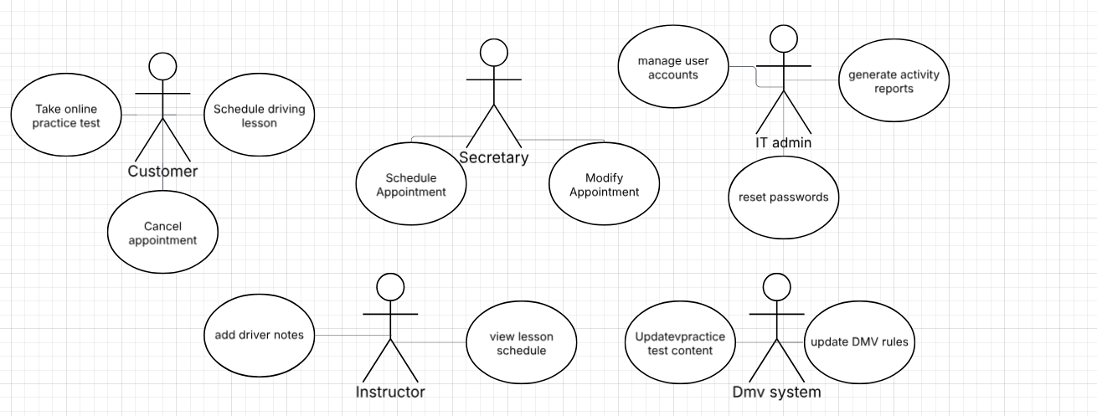

UML Activity Diagrams

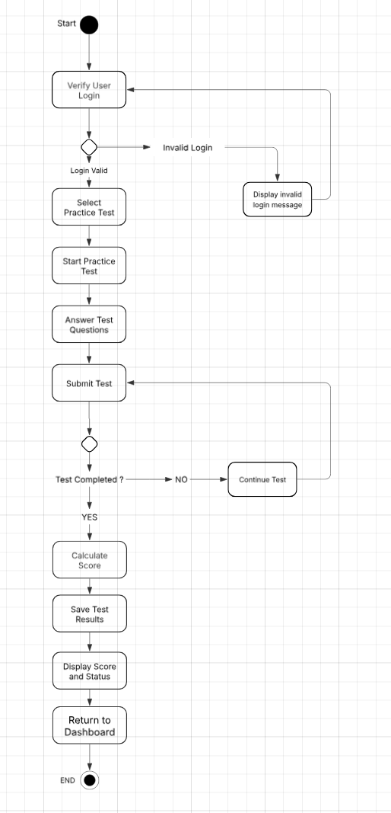
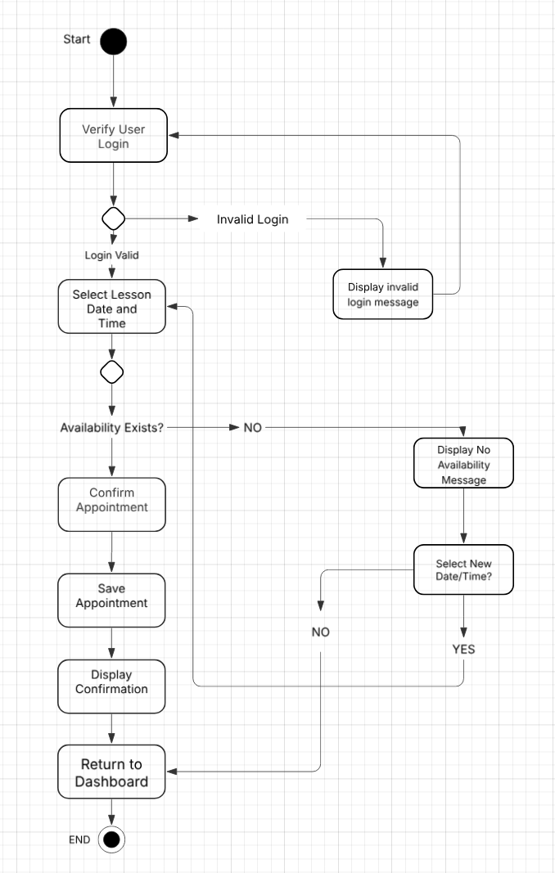

UML Sequence Diagram
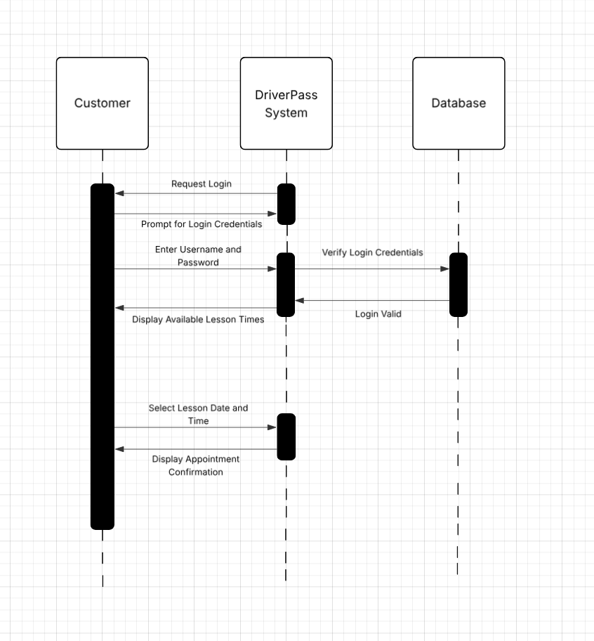

UML Class Diagram
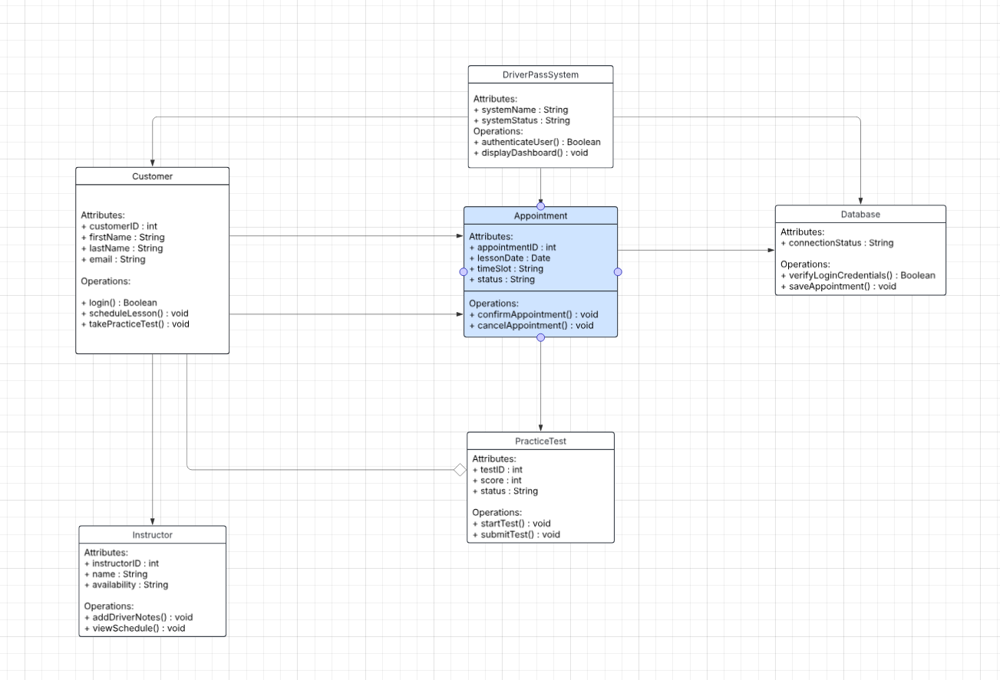

Technical Requirements
Based on the system design and diagrams, the Driverpass system is a web based application that can be used on computer and mobile devices with internet access. This allows customers, instructors, and staff to log in and use the system from different locations without special hardware.
The system requires cloud base storage and a database to store user accounts, appointments, test results, and all other data. The database is used to verify logins and save scheduling information.
The system also requires basic web software to handle user logins, scheduling, appointments, and test features. Standard web browsers are used to access the system.

